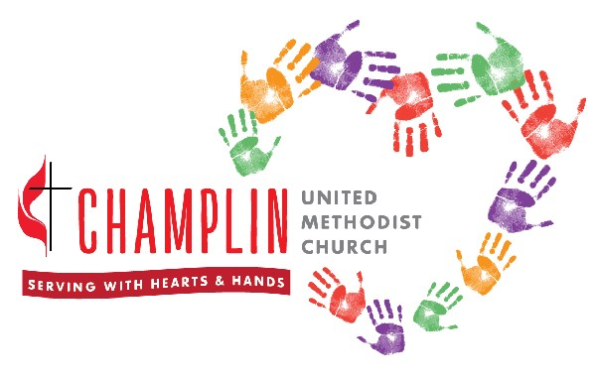
Registration Form Date: ________
Youth and Children's Education Activities
Name: _____________________________________
Date of Birth: ______________ Grade in Fall: ___________

Parent/Legal Guardian: _______________________________________________________
We will use an email list for routine contacts about upcoming activities, etc., so please make sure we have your current email address. If you prefer not to be contacted by email, please note this preference on the "email" line. Thanks!
Address: ______________________________________________
______________________________________________
______________________________________________
Phone: ___________________ Mobile: ___________________ Circle # to be used in emergency.
Email: ________________________________________@__________________________

Parent/Legal Guardian: _______________________________________________________
Address: ______________________________________________
______________________________________________
______________________________________________
Phone: ___________________ Mobile: ___________________ Circle # to be used in emergency.
Email: ________________________________________@__________________________

Emergency Contact Name___________________________ Relationship___________________
Phone __________________________

For the above participant, please list the following information (use back of form for additional information):
Allergies/Asthma: ________________________________________________________________
Special Dietary Need(s): ___________________________________________________________
Current Medical Conditions: ________________________________________________________
Current Medications: ______________________________________________________________
Primary Physician: _______________________________ Telephone: _______________________
Clinic Location/Address: ____________________________________________________________

I give my child permission to participate in the children/youth programs at Champlin United Methodist Church (CUMC). I assume the risk of my child's participation and wholly release CUMC community, CUMC staff, and CUMC leaders from any responsibility or liability, waive any claim or causes of action against, and agree to hold harmless CUMC, CUMC staff and CUMC leaders in the event any such claim should arise due to injury, illness, loss, death, or accident. I understand that in the case of an emergency, every attempt will be made to contact me as parent or guardian using the information provided on this sheet.

In the event that I cannot be reached, I give permission for the emergency contact listed to be called. In case I cannot be reached and care is needed immediately, I give permission for my child to be taken to the hospital for the area that is needed. I further direct that the hospital and its physicians have my permission to care for my child.

_______________________________________________________ _____________________
Signature of Parent/Guardian Date

Champlin United Methodist Church

Photo/Video Release Form

Media images and recordings help us share our story as a vibrant, inclusive and friendly church community. Accordingly, participation in church activities implies permission for publication of photos and video recordings in church-produced materials such as bulletins, posters, brochures, newsletters, the church website and social media. This applies to anyone age 18 and older who attends our church.

We need the permission of a parent or guardian before using images of children on our website, in any social media posts, or in printed materials. We will always strive to follow our photo and privacy policies (copy attached) and will not include children's last names, addresses, phone numbers or email addresses with any image that is used publicly.
I grant to Champlin United Methodist Church, the right to take photographs of my child and my family in connection with church related classes and events. I authorize Champlin United Methodist Church, its assigns and transferees to copyright, use and publish the same in print and/or electronically, subject to the church's photo and privacy policies.
I agree that Champlin United Methodist Church may use such photographs of my child and family with or without my name and for any lawful purpose, including for example such purposes as publicity, illustration, advertising, and Web content.
I have read and understand the above: If you do not want any photos of your child(ren)
To be used for church purposes, please note that
Signature _________________________________ here:

Printed name ______________________________ ________________________________________

Address __________________________________ ________________________________________

Phone ___________________________________

Date _____________________________________

Name of child ____________________________________________

